Strolling on the banks of the Sumida River from Azuma-Bashi Bridge to Sakura-Bashi Bridge.

Up the Riverside

Azuma-Bahsi Bridge

Near the Asakusa station on Ginza-Line, there is a red bridge with 150M

overall length, spanning the Sumida River between Kaminarimon district

on the westside of the bank and Azumabashi district on the eastside of

the bank. It is called “Azuma Bashi Bridge”.

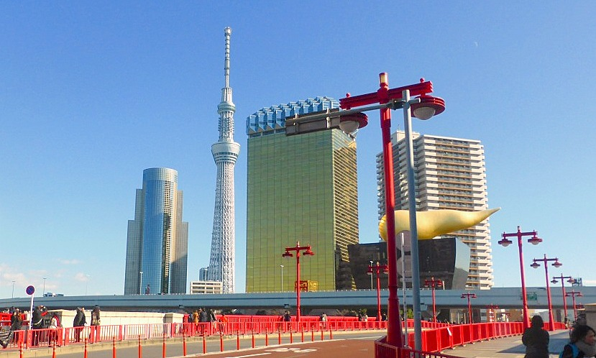

The original bridge was constructed in the middle of Edo period in 1774.

After repeated damage and rebuilt, the current bridge was established in

1931. The name of the bridge “Azuma” comes from “Azuma-Shrine” which is

located way ahead on the eastside of the river. It is said that the name of

“Azuma” means “my dear heart”.

On the east side of “Azuma-Bashi Bridge”, there is the Asahi-Brewery

-Super-Dry-Hall on which a gold colored object is horizontally rested.

The object has a figure like a cloud. On the left side of the hall there stands

a gold colored tour of Asahi brewery head office. Further behind these

buildings, the Tokyo Skytree rises up into the sky.

From the west edge of the bridge, one can get best view of all the 3 buildings

together and can take one shot picture of the whole complex.

The firework display is held on the last Saturday in July every year in this

area. It is an annual summer event which has taken place since Edo period.

Nearly one million people gather this area and watch around 10,000 colorful

fireworks setting off in the night sky on both banks of the river. Some of them

charter “Yakata-Bune“which is a roofed pleasure boat with Tatami-mats room

and they view splendid images reflected on the surface of water as well as

spectacle above their head. It is really a summer charm to enjoy the gleam,

color, sound and even smell of fireworks in nice breezing passing over

Sumida River.

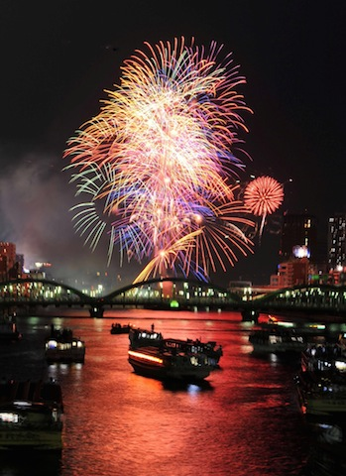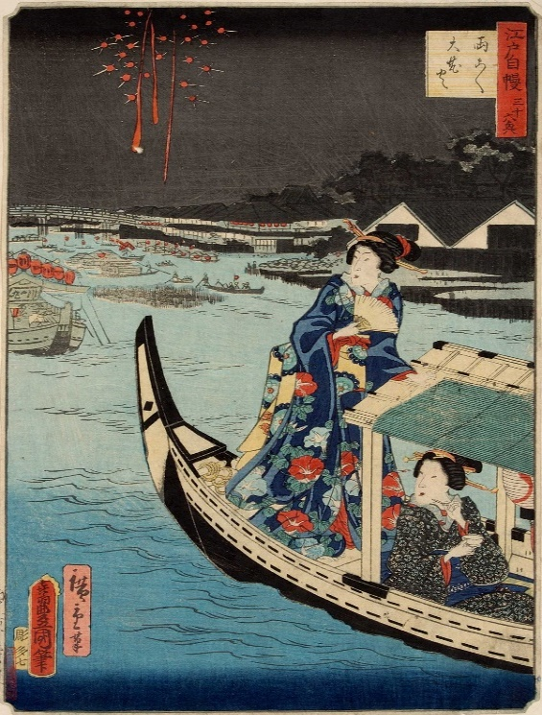

There is a pier for pleasure boats at the west edge of Azuma-Bashi Bridge

near Asakusa Station on Ginza-Line. We are able to enjoy the cruising down

Sumida River from Asakusa up to near Tokyo Bay. The boat is in daily service

at almost hourly intervals on the route from Asakusa to Hinode-Pier, Odaiba

Seaside Park, Pallette Town, Tokyo Big Sight, Hamarikyu Garden and then

Toyosu.

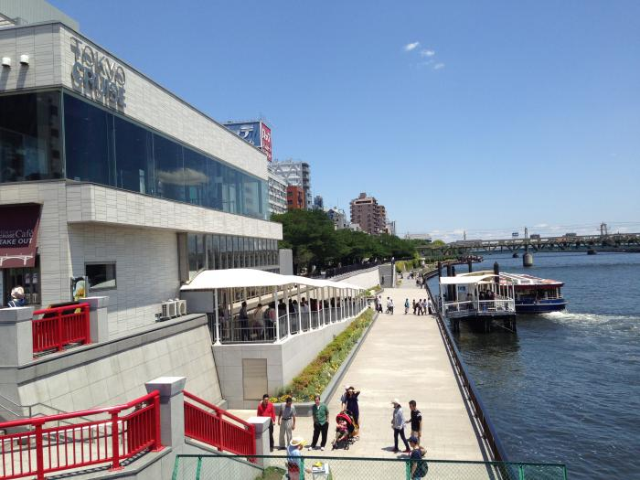

Going farther along the river from Azuma-Bashi Bridge, we enter the Sumida

Park which spreads along the both sides of the river up to Sakura-Bashi bridge.

Various annual events have been conducted in this park. For instance, Plum

festival in February, Cherry blossom festival in March, “Yabusame ceremony”

(The art of shooting arrows on running horseback) in April, Festival of

Hydrangea flower in June and “Toro Nagashi” ([Sending off](http://ejje.weblio.jp/content/sending+off) the [spirits of the dead](http://ejje.weblio.jp/content/spirits+of+the+dead) [on](http://ejje.weblio.jp/content/on) [lanterns](http://ejje.weblio.jp/content/lanterns) [floated](http://ejje.weblio.jp/content/floated) [on the](http://ejje.weblio.jp/content/on+the) [water](http://ejje.weblio.jp/content/waters) [of a](http://ejje.weblio.jp/content/of+a) [river](http://ejje.weblio.jp/content/river) on the last day of Bon

festival).

Especially this park has been well known as one of the best cherry blossom

viewing site since Edo Period. It is splendid to view full blooming flowers on 600 of cherry trees lined on the both banks of Sumida River.

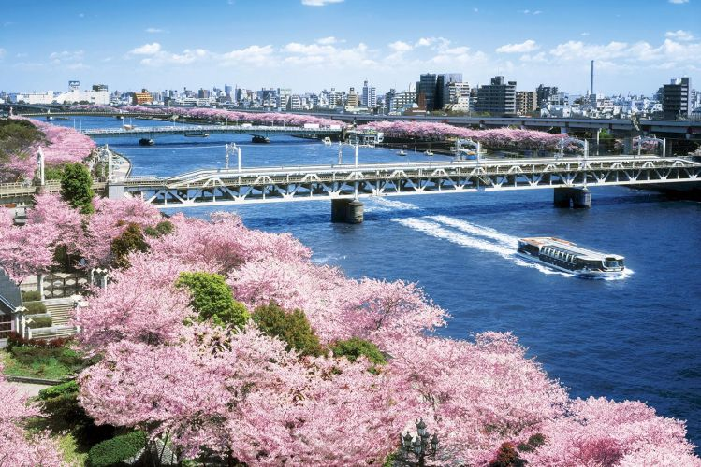

Kototoi-Bashi Bridge

Farther heading the park, a blue-green colored bridge appears in front. It is called Kototoi-Bashi Bridge.

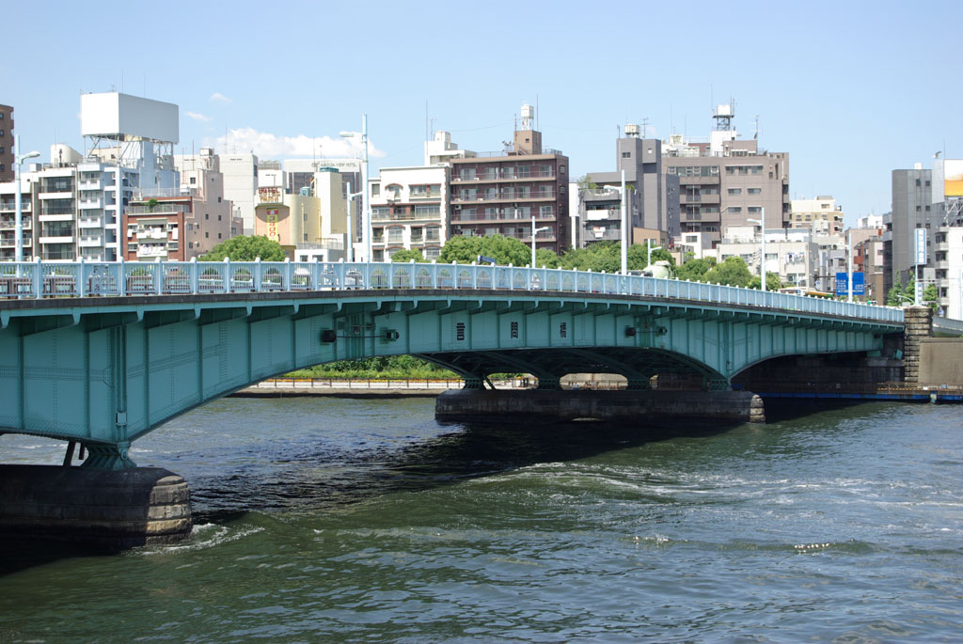

The place several hundred meters before the bridge is the best spot to take

a picture of Tokyo Skytree which is reflected on facade of the building of Asahi

Brewery head office on the other side of the river. The Skytree being reflected

on it is deformed and is very much different from its usual gothic style.

The deformed figure of Skytree might draw one’s interest.

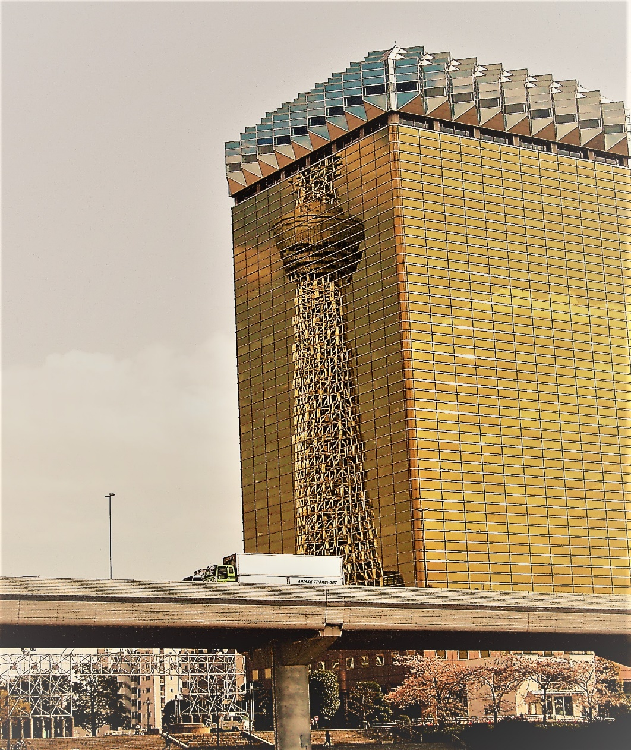

Passing by the Kototoi-Bashi Bridge and going farther ahead, an emerald

green colored roof with twin ridges comes into sight on the left side of

the bank. It is Buddhist temple named “Honryuu-In-Matsuchiyama-

Shouden”.

According to a Legend, a small mound suddenly rose up from the river bed

and then a gold dragon flew around over the mound more than 1400 years

ago. After 6 years from the happening, a god called “Daishou-Kangi-Ten” with

elephant’s head descended to the mound and saved people who were suffering

from serious famine due to drought. Since then people erected the temple on

the mound and worshipped the god there. The image of the god has twin

bodies each with elephant’s head in an embrace. It is said that the god

originates from Indian god Ganesha.

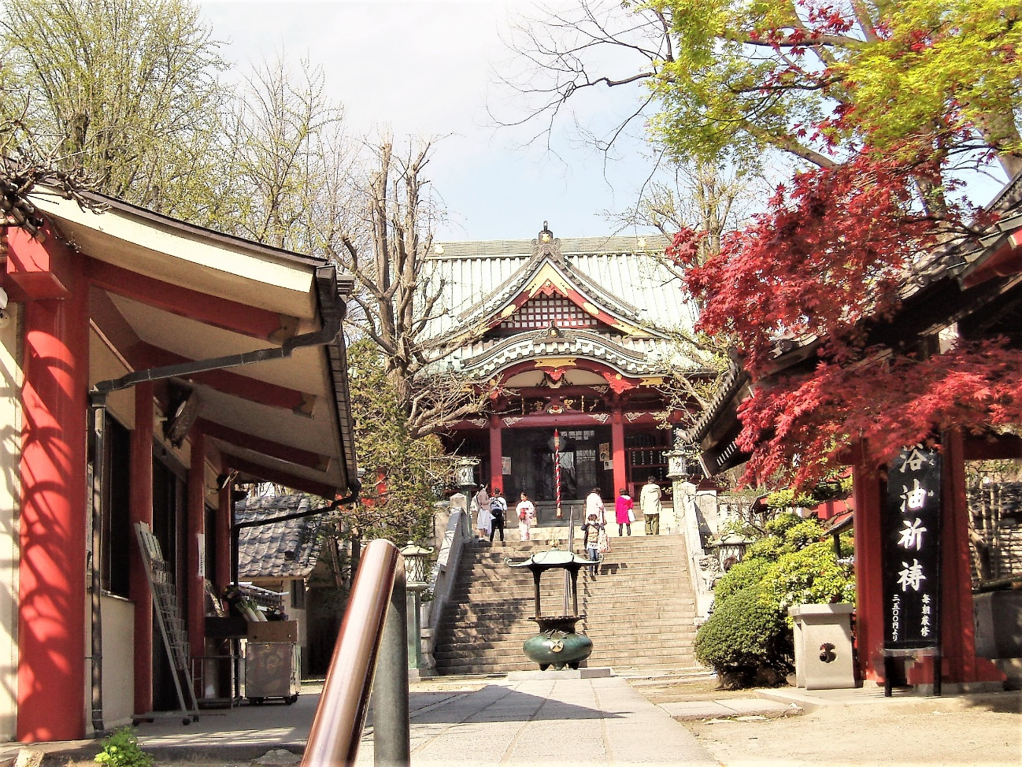

The emblem of the temple is a combination of a pouch being filled with placer

gold and a white radish with forked roots. The pouch stands for wealth and

prosperity. The radish means sound health, matrimonial harmony and

prosperity of descendants. The god, “Daishou-Kangi-Ten”, is said to bless

people with those benefits.

The Radish is carved in relief in the banisters of the stone steps at the entrance. People dedicate a white radish to the god and pray for their wishes on Radish Festival on the 7th day of January every year.

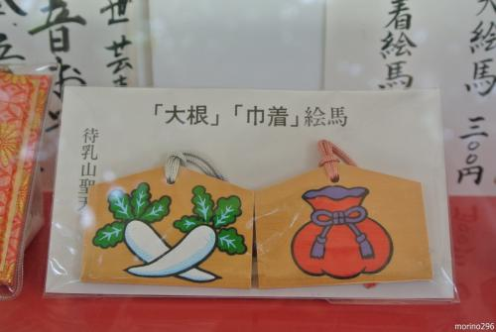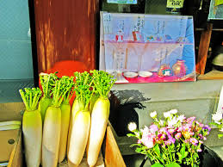

On the right side of the prayer’s hall, there is a Japanese style garden

where red, white and yellow colored carps are swimming in a small pond

,and a pinkish cherry blossom is in full bloom, a peony tree is coming into

bright reddish flowers and a citrus tree is bearing yellow oranges.

It is tiny but colorful and tasteful garden.

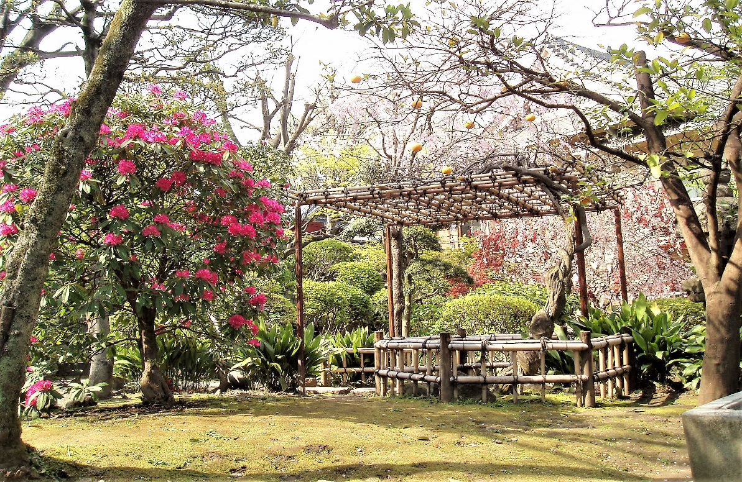

Sakura-Bashi Bridge

Returning to the riverside and proceeding ahead, an orange colored bridge

comes into sight in front of the Riverside Sporting Center. The bridge

uniquely forms X-shape and then the ends respectively bifurcate to the both

banks of the river. The bridge is called Sakura-Bashi Bridge which is utilized only for a pedestrian walkway.

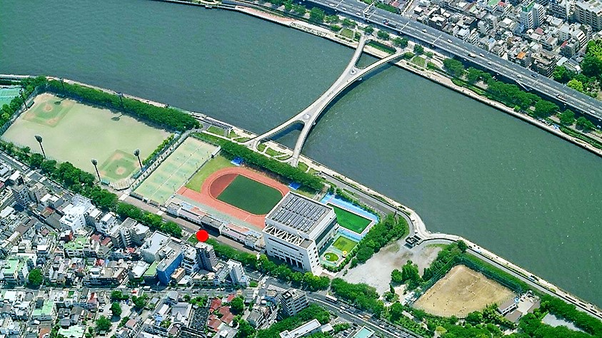

Going across the bridge, there is a Buddhist temple named “Choumei-Ji”

of Tendai Sect Buddhism on the left side, which was established by a high

ranked priest named Ennin of Enryaku-ji Temple in Kyoto about 400 years

ago.

At the riverside of the temple ground, a sweet shop named “Gekkourou”

has been selling a Japanese cake called “Sakura Mochi” (A lump of sweet bean

paste is wrapped in a pinkish crepe and in pickled cherry-leaves.) since

the middle of Edo Period around 300 years ago. People can taste

the traditional sweet with green tea at reasonable price inside the shop.

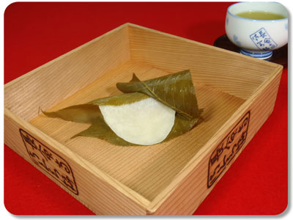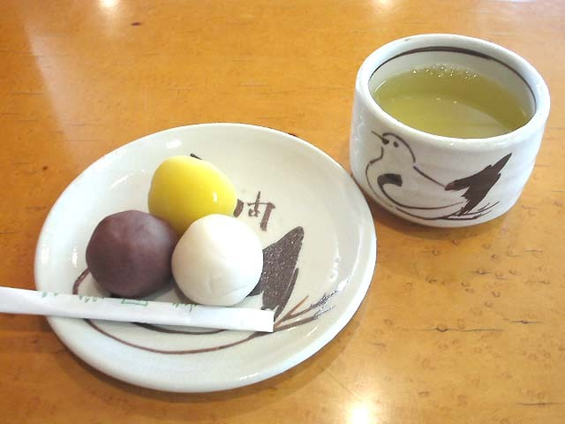

In addition there is other sweet shop upriver near “Gekkourou”.

The shop is called, “Mukoujima Kototoi-Dango” who is selling a sweet bean paste dumpling since around 140 year ago. They serve 3 varieties of dumplings being made of red bean paste or white bean paste or yellow paste containing soya bean jam.

These two traditional sweets have been favored by cherry blossom viewers.

They take a short breath to taste the sweets at these shops even now. It is

the same as it used to be in good old days.

Down the riverside from Sakura-Bashi Bridge to Kototoi-Bashi on the east

bank of the river.

Going down the riverside from Sakura-Bashi bridge, a small modest shrine

named ”Mimeguri-Jinjya”, is located on the left side of the river before

Kototoi-Bashi bridge.

A priest of Miidera Temple in Oomi (Current Shiga Prefecture) named

“Genkei” dropped by this site during his trip to East Japan and found

a small desolate shrine. And when he dug the ground to rebuilt it, he found, an image of graybeard riding on a white fox came out of a quaint pot. It was

holding an orb in the right hand and an ear of rice in the left hand.

Suddenly a white fox appeared out of nowhere, and run around the priest

3 times and passed away. The name of the shrine is originated in the 3 times

of the run-about. Following the mysterious number 3, a unique shape of

Torii-gate with 3 pillars are standing on the back side of the shrine building.

Usually most of torii-gate is provided with 2 pillars.

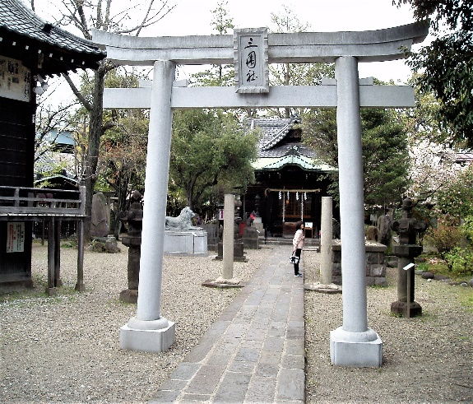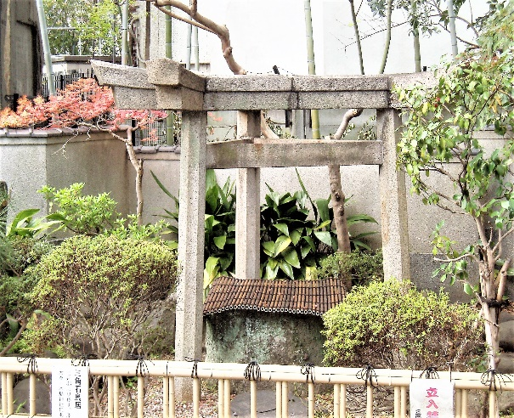

The Mimeguri shrine has been worshipped as guardian deity by the Mitsui

Combine which is based in Nihonn-bashi district in Tokyo (once called Edo

city), because the shrine located in the north-east seeing from Nihon-Bashi

and also people believed that the gate of devil’s invasion is situated in that direction.

The shrine deified successive heads of Mitsui family who passed away more than 100 years ago. In this connection, Mitsukoshi department store is deeply related with this shrine. Their commercial mascot, bronze lion statue was contributed and is being installed in front of the shrine.

Kototoi-Bahsi Bridge

A roof of shrine building is observed over trees on the left-hand side after

passing by Kototoi-Bashi Bridge. It is named “Ushijima-Jinjya Shrine”.

About 1,300 years ago there used to be a part of a state-run farm called

“Ushijima” where herds of cows were grazing peacefully. The name of

the shrine comes from the area.

In Edo period, there was the suburban residence of feudal lord, Mito family

who governed the current Ibaraki prefecture.

Ushijima shrine worships “Susanou-No-Mikoto”, who was a brave deity

described in Japanese mythology. He was governing “Izumo” area (Current Tottori prefecture). It is said that “Susanou-No-Mikoto” in Shintoism was

synchronized with “[Gozu](http://ejje.weblio.jp/content/Gozu) [Tenno](http://ejje.weblio.jp/content/Tenno)” in Buddhism who is [deity](http://ejje.weblio.jp/content/deity) [to be](http://ejje.weblio.jp/content/said+to+be) [the Indian](http://ejje.weblio.jp/content/the+Indian) [god](http://ejje.weblio.jp/content/god) Gavagriva.

The Gozu-Tenno is originally a guardian deity of Jetavana [Monastery](http://ejje.weblio.jp/content/Monastery) in [India](http://ejje.weblio.jp/content/India) as well as guarding against epidemics.

The shrine building and its Torii-gate stand with a dignified appearance.

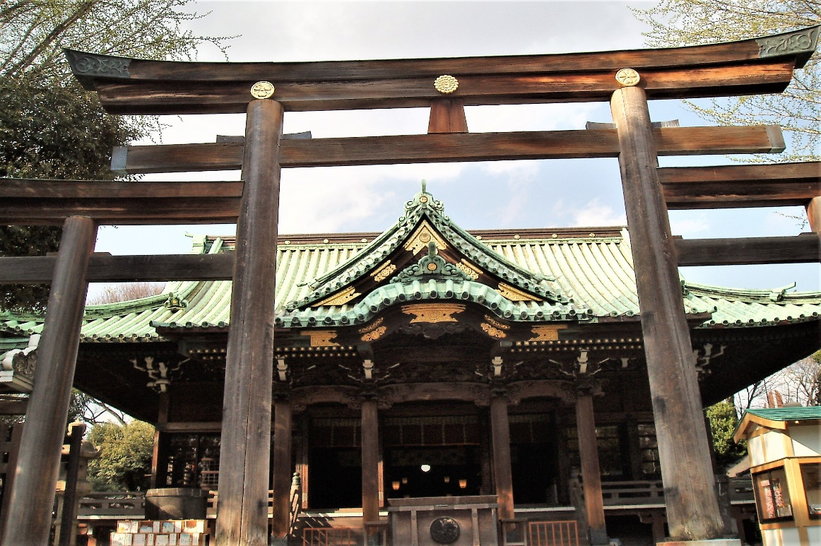

The shrine is also displaying a cow statue wearing a red bib around its neck at the corner of its precincts. It is familiar to people as “Stroking Caw” which

has a supernatural power. It is believed that an afflicted part is cured if one would stroke the part of its body and then the corresponding one on the statue of the cow. Once every 5 years the noble and graceful carriage is drawn by a black ox along with believers in traditional manner, praying for peace and security of the area.

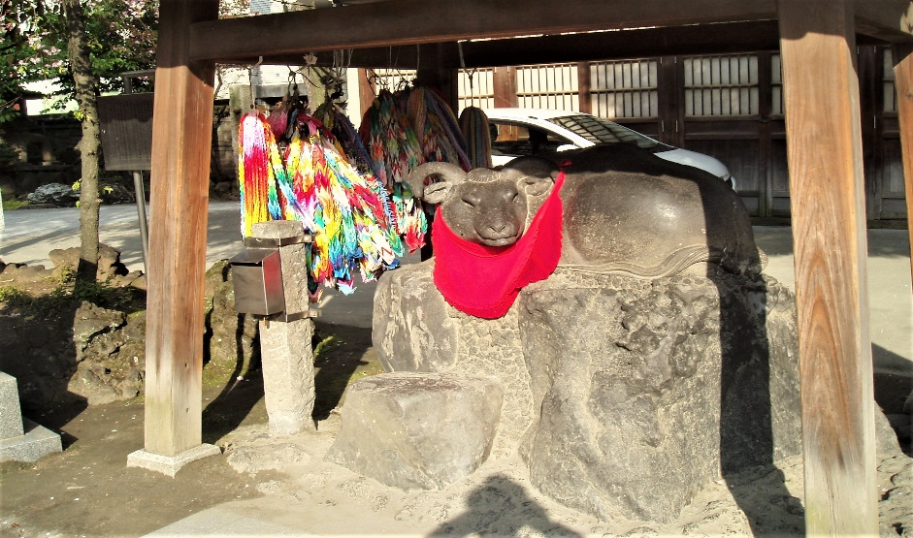

A beautiful Japanese garden spreads over outside the shrine. It used to be one of residence of Mito family, feudal lord in Mito area in Edo period.

It survives as one part of Sumida park. There are an aesthetic stone lantern

and a pond where a tiny islet is arranged at its center.

It is worth viewing once.

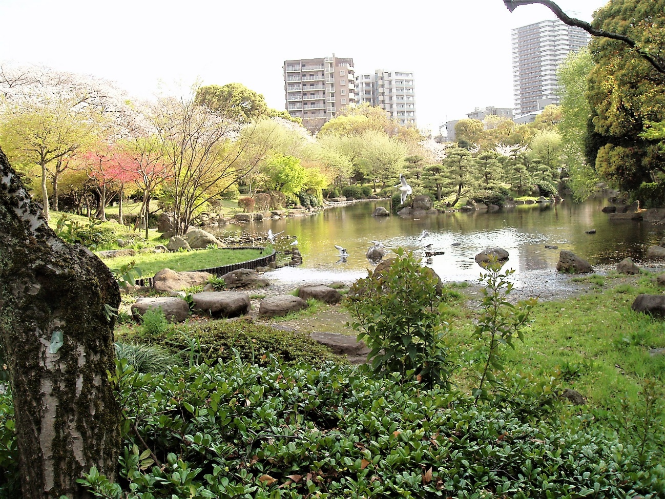

Azuma-Bashi Bridge

Passing through the Sumida park, the 22-story building of Asahi Brewery

head quarter and the Asahi-Brewery-Super-Dry-Hall are coming into sight.

These are the buildings which were observed at the west end of Azuma-Bashi

Bridge on the opposite side of bank.

The Super-Dry-Hall was erected in 1989. The object on the hall is really

a unique shape looking like a golden billow of foamy cloud. It becomes

a landmark in the riverside area.

It was designed by Phillippe Starck, a French industrial designer.

He designed the object so as to express golden burning flames (Flamme D’or)

with his inspiration from Olympic flame. The black building of the hall is showing a pedestal for Olympic flame.

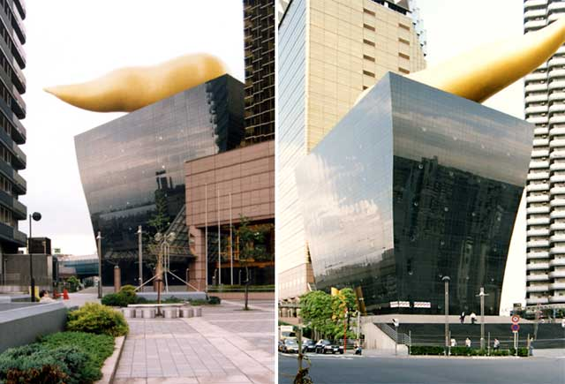

It is said that the whole figure of head quarter building is showing a beer mug

and the jagged roof top is expressing froth on beer. People can taste variety

of Asahi beer which are directly delivered by Asahi Brewery’s plant, in both

buildings. It is so nice to enjoy draft beer and craft while looking over

the riverside scenery from the 22rd floor. Especially it is the best to quench

thirsty throat with the cold beer named “Super Dry Extra Cold”

. 

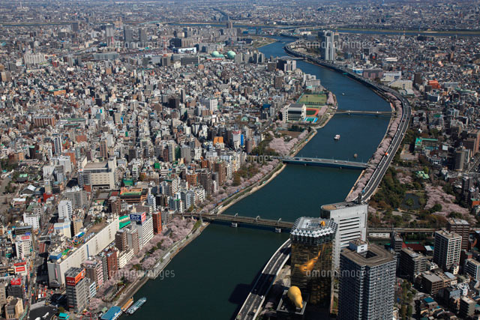

Finally crossing Azuma-Bashi bridge in a breezing through Sumida river, one can reach the starting point of the entire strolling which is near the Asakusa Station. It is about 3.5 hours’ short trip

